**NAAN MUDHAVAN**

**ASSIGNMENT DOCUMENT**

**COURSE TITLE** : DIGITAL MARKETING

**COLLEGE CODE** : 1105

**COLLEGE NAME** : GOJAN SCHOOL OF BUSINESS AND TECHNOLOGY

**NM ID** : 940480FE4060964BC8C4A247AF711E83

**NAME** : UTHAYAKANI. R

**REGISTER NUMBER** : 110520106340

**YEAR** : 4TH YEAR

**DEPARTMENT** : ELECTRONICS AND COMMUNICATION ENGINEERING

1. Create a blog or website using Blogspot and Wordpress. Customize the theme design and post new article with 500 words.

Link:

https://uthayakani47.blogspot.com/2023/10/engineers-cafe-we-are-arrived.html?m=1

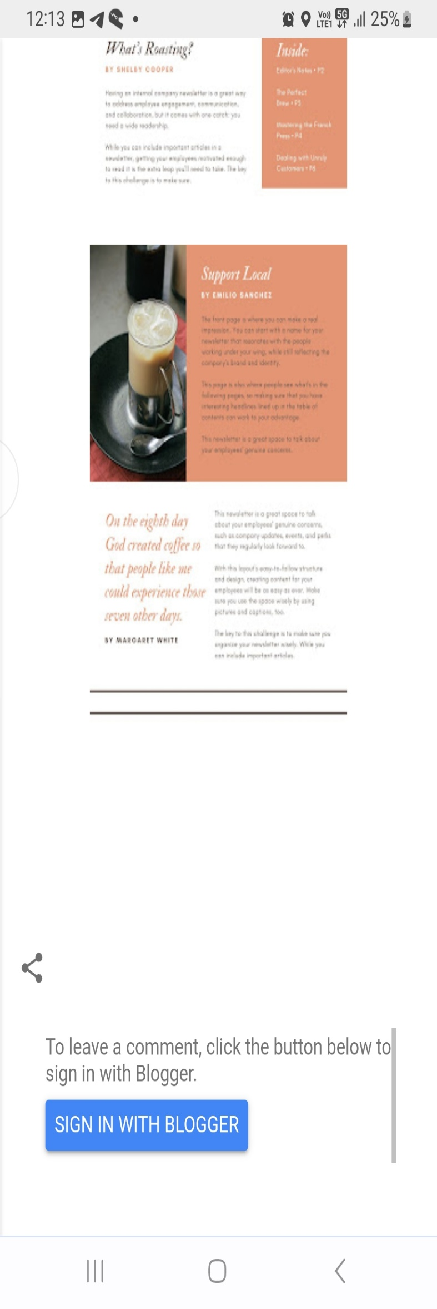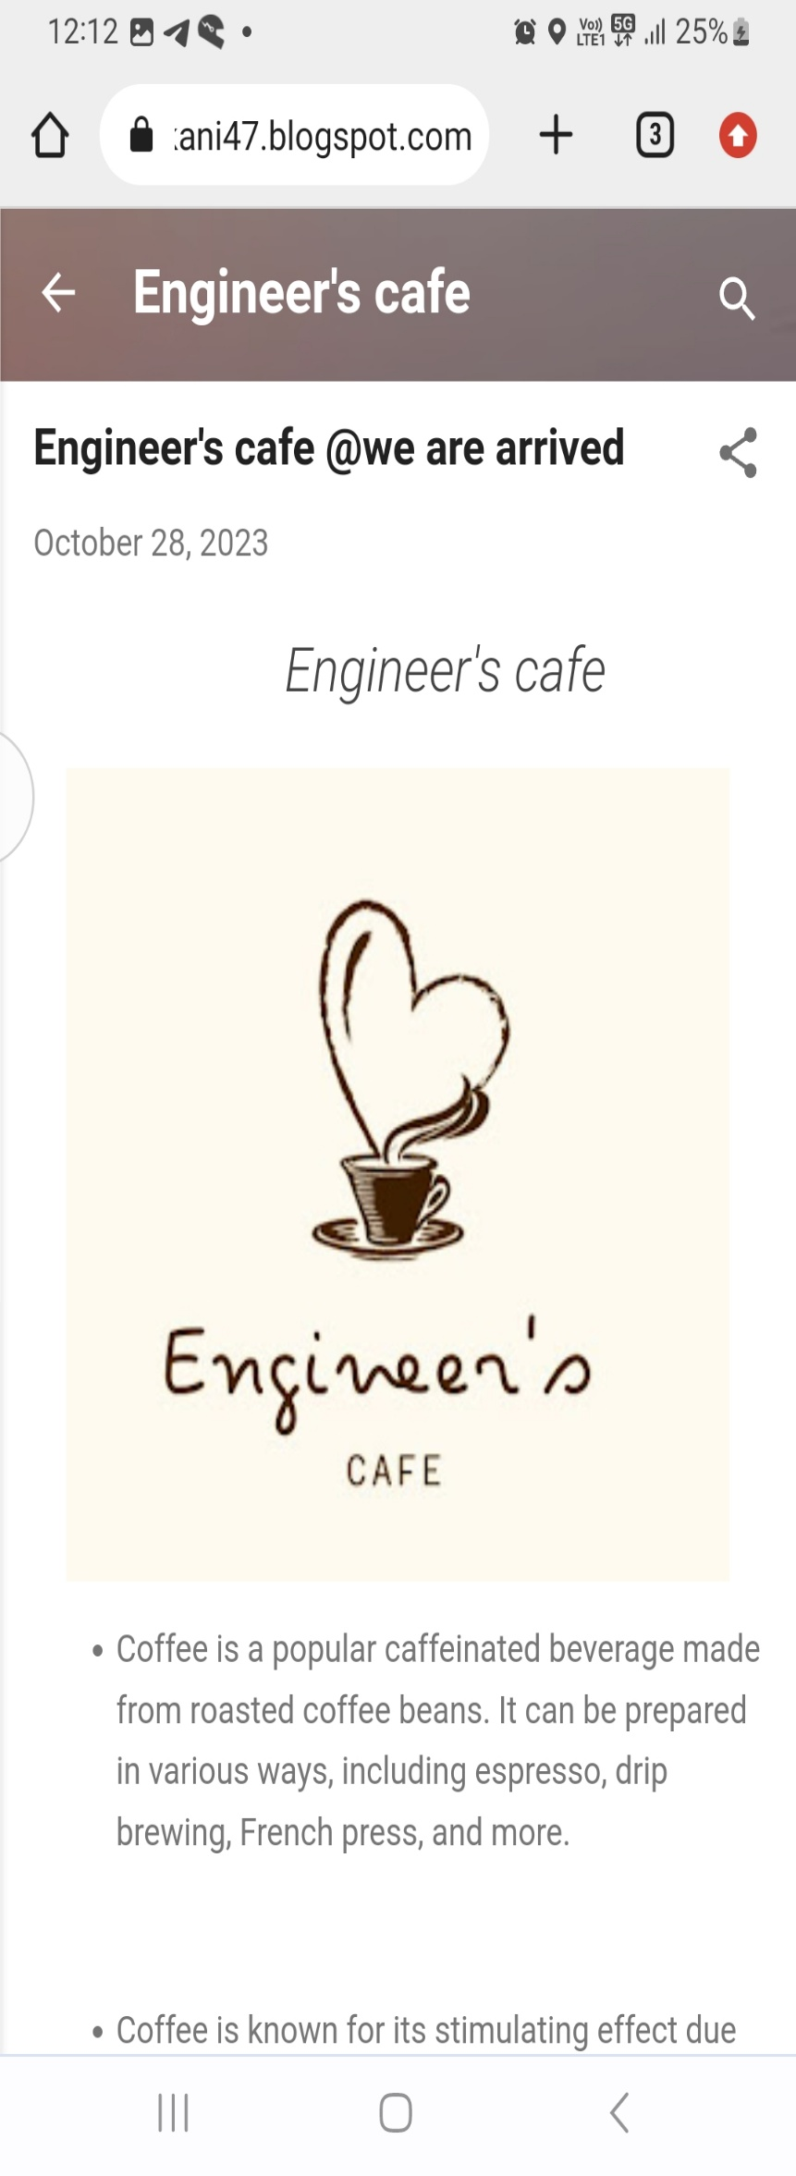

1. Create a New Facebook Business Page and post one social media poster for your brand.

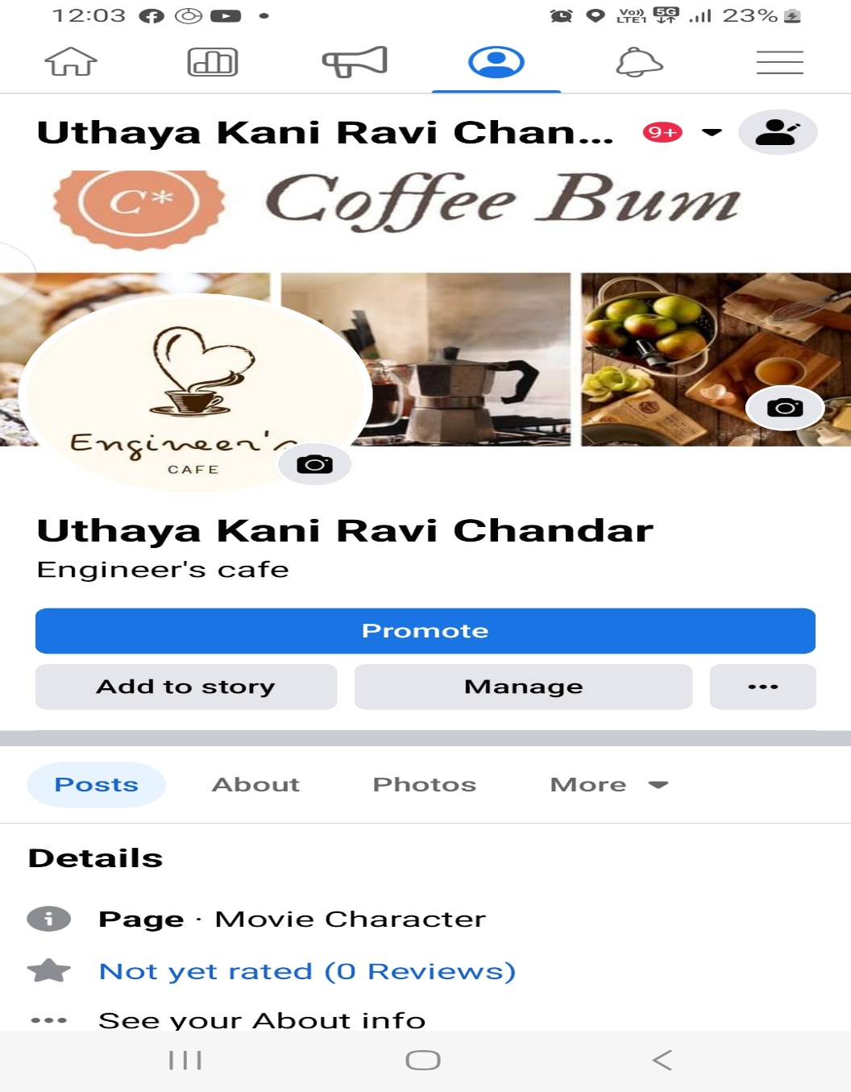Link: <https://www.facebook.com/profile.php?id=100072401554727&mibextid=ZbWKwL>

1. 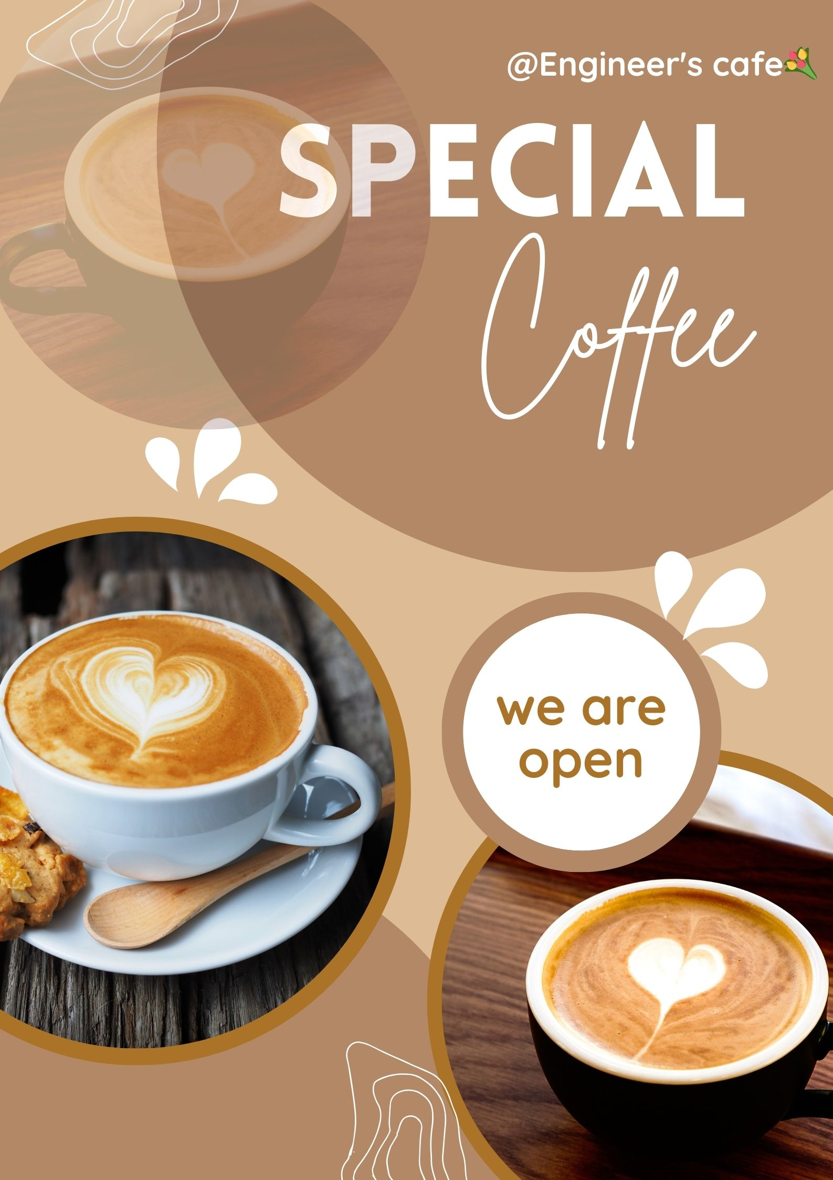Create and design a social media advertisement poster using canva.
2. Create email newsletter design using MailChimp or canva tool.

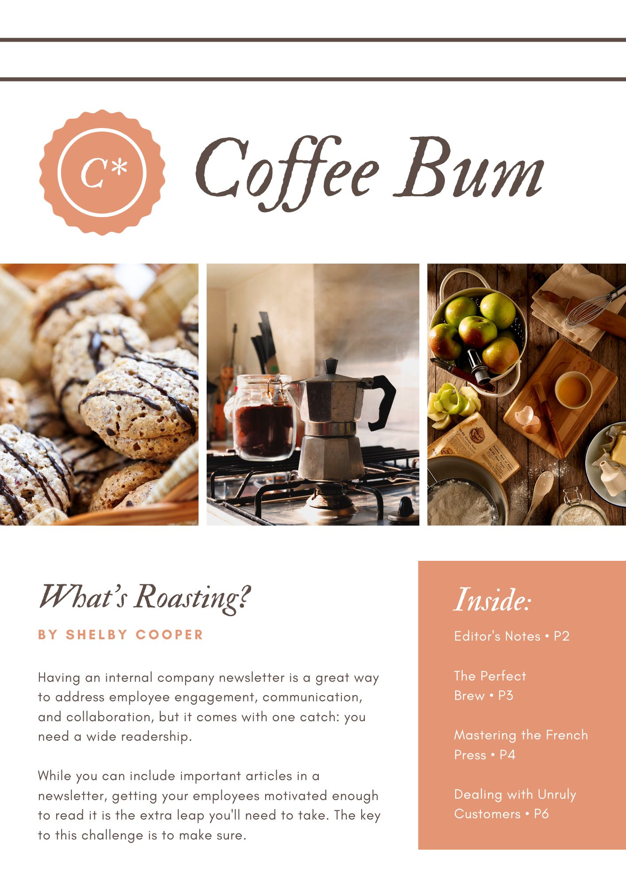Link : https://uthayakani47.blogspot.com/2023/10/engineers-cafe-we-are-arrived.html?m=1